1. Run the following MDX query and show the results.

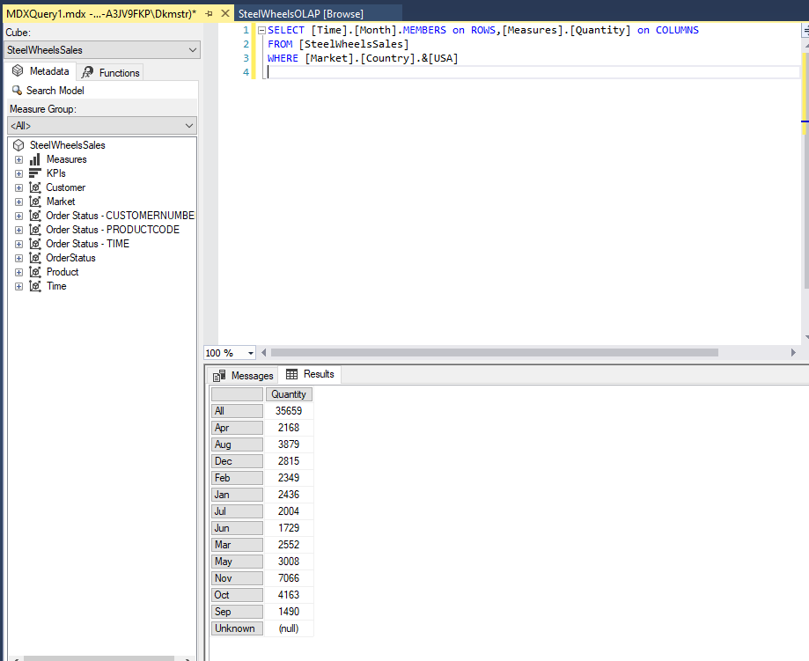**RESULTS:**

1. In the result of the following MDX statement,

SELECT CrossJoin({[OrderStatus].[Disputed],

[OrderStatus].[Resolved]}, {[Measures].[Sales],

[Measures].[Quantity]}) ON COLUMNS,

{[Product].[Line].&[Classic Cars], [Product].[Line].&[Planes]} ON ROWS

FROM [SteelWheelsSales]

WHERE ([TIME].[2005])

Which one of the statements is correct?

|  |  |  |  |  |
| --- | --- | --- | --- | --- |
|  |  |  |  |  |
|  |  |  |  |  |
|  |  |  |  |  |
|  |  |  |  |  |

* default measures appear in the result
* the COLUMNS axis only shows the Sales and Quantity measures.
* **the COLUMNS axis is stacked with the [OrderStatus] dimension members ([Disputed] and [Resolved]) and the sales and quantity measures.**
* the COLUMNS axis is stacked with all [OrderStatus] dimension members and the sales and quantity measures.

1. A MDX query without slicers was made against SteelWheelsSales OLAP cube and the following results were shown. Write down the MDX query.

**Results:**

|  |  |  |  |  |
| --- | --- | --- | --- | --- |
|  | All | 2003 | 2004 | 2005 |
|  | Sales | Sales | Sales | Sales |
| All | 1.06E+07 | 3677384 | 4987740 | 1980825 |
| Apr | 793286.6 | 201609.5 | 206148.1 | 385528.9 |
| Aug | 659310.5 | 197809.3 | 461501.2 | (null) |
| Dec | 778820.6 | 303494.2 | 475326.5 | (null) |
| Feb | 817721 | 140836.2 | 318698.6 | 358186.3 |
| Jan | 785874.5 | 129753.6 | 316577.4 | 339543.5 |
| Jul | 588542.1 | 225486.2 | 363055.8 | (null) |
| Jun | 538686.8 | 170559.3 | 368127.4 | (null) |
| Mar | 830178.5 | 174504.9 | 242143.1 | 413530.5 |
| May | 950147.8 | 192673.1 | 273438.4 | 484036.3 |
| Nov | 2175769 | 1086721 | 1089048 | (null) |
| Oct | 1142888 | 589963.9 | 552924.3 | (null) |
| Sep | 584724.1 | 263973.3 | 320750.8 | (null) |

**MDX:**

I have absolutely no idea how to do this, and am way out of time.

1. In an MDX statement, a slicer is specified in which clause

* **SELECT**
* Nested SELECT statements
* WHERE
* FROM

1. What statements are true about axis and slicer dimensions?

* **Axis dimensions are shown in the row and column headings of the cube result.**
* **A dimension can be used as both an axis and a slicer.**
* Slicer dimensions are mandatory.
* **Slicer dimensions do not appear in the row and column headings of the cube result.**
* Axis is a synonym for slicer.

1. If the TIME dimension is added in the SELECT clause, the following MDX statement in SSMS is:

SELECT CrossJoin({[OrderStatus].[Disputed],

[OrderStatus].[Resolved]}, {[Measures].[Sales],

[Measures].[Quantity]}) ON COLUMNS,

{[Product].[Line].&[Classic Cars], [Product].[Line].&[Planes]} ON ROWS

FROM [SteelWheelsSales]

WHERE ([TIME].[2005])

* valid if the [TIME] dimension is added to the ROWS axis
* valid if the [TIME] dimension is added to the COLUMNS axis
* valid if the [TIME] dimension is added as an additional axis
* **invalid because a slicer dimension cannot appear in the axis**

1. If no measures appear in the SELECT clause of an MDX statement,

* the statement is not valid.
* the user is prompted for a measure name.
* a WHERE clause is required.
* **the default measure is shown in the cells.**